製作Servlet Session
如果你想要在瀏覽器與Web應用程式的瀏覽期間，保留請求之間的相關訊息，則可以使用HttpSession的setAttribute()方法將相關訊息設置為屬性。如果想取出這些資訊，則透過HttpSession的getAttribute()就可以取出。你完全可以從Java應用程式的觀點來進行session管理，而不用理會HTTP無狀態的事實。
步驟
- 打開檔案總管，找到C:\apache-tomcat-7.0.42\webapps\ROOT，新增資料夾LabLogin。
- 在C:\apache-tomcat-7.0.42\webapps\ROOT\LabLogin下，新增login.xml。
<html>
<head></head>
<body>
<form action="/login.do" method="post">
User Name:<input type="text" name="user" /><br/>
Password:<input type="password" name="password" /><br/>
<input type="submit" name="submit" value="登入">
</form>
</body>
</html>
- 編譯 Login.java

import java.io.*;
import javax.servlet.*;
import javax.servlet.annotation.*;
import javax.servlet.http.*;
@WebServlet(name = "Login", urlPatterns = {"/login.do"})
public class Login extends HttpServlet {
@Override
protected void doPost(HttpServletRequest req,
HttpServletResponse resp) throws ServletException, IOException {
String user = req.getParameter("user");
String password = req.getParameter("password");
if ("john".equals(user) && "12345".equals(password)) {
req.getSession().setAttribute("login", user);
req.getRequestDispatcher("/user.view").forward(req, resp);
} else {
resp.sendRedirect("/LabLogin/login.html");
}
}
}
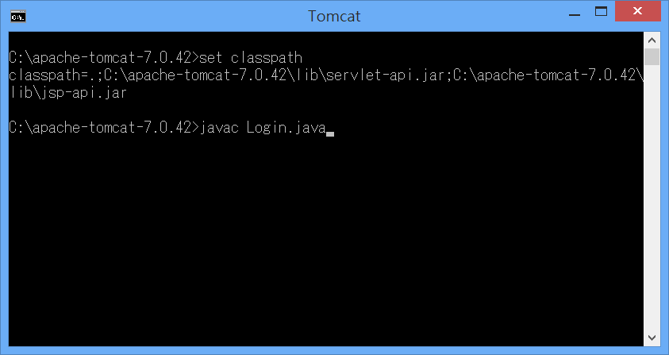
- 編譯 UserView.java

import java.io.*;
import javax.servlet.*;
import javax.servlet.annotation.*;
import javax.servlet.http.*;
@WebServlet(name = "User", urlPatterns = {"/user.view"})
public class UserView extends HttpServlet {
protected void processRequest(HttpServletRequest request,
HttpServletResponse response) throws ServletException, IOException {
HttpSession session = request.getSession();
if (session.getAttribute("login") == null) {
response.sendRedirect("login.html");
} else {
response.setContentType("text/html;charset=UTF-8");
PrintWriter out = response.getWriter();
out.println("<html>");
out.println("<head>");
out.println("<title>歡迎 "
+ session.getAttribute("login") + "</title>");
out.println("</head>");
out.println("<body>");
out.println("<h1>Servlet User " +
session.getAttribute("login") + "</h1><br><br>");
out.println("<a href=\"logout.do\">登出</a>");
out.println("</body>");
out.println("</html>");
out.close();
}
}
@Override
protected void doGet(HttpServletRequest req, HttpServletResponse resp)
throws ServletException, IOException {
processRequest(req, resp);
}
@Override
protected void doPost(HttpServletRequest req, HttpServletResponse resp)
throws ServletException, IOException {
processRequest(req, resp);
}
}
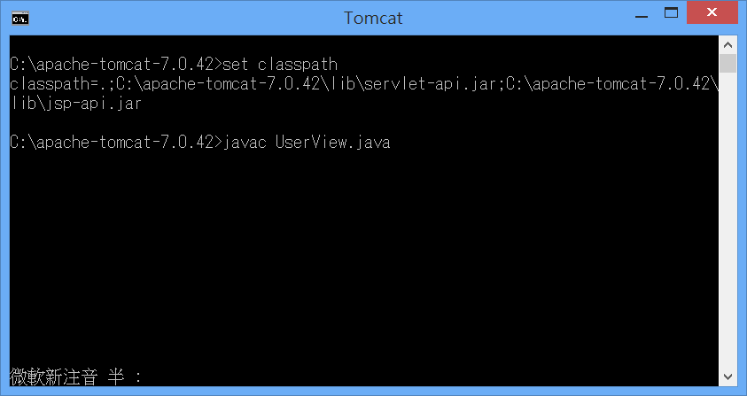
- 編譯 Logout.java

import java.io.*;
import javax.servlet.*;
import javax.servlet.annotation.*;
import javax.servlet.http.*;
@WebServlet(name="Logout", urlPatterns={"/logout.do"})
public class Logout extends HttpServlet {
protected void processRequest(HttpServletRequest req,
HttpServletResponse resp) throws ServletException, IOException {
req.getSession().invalidate();
resp.sendRedirect("/LabLogin/logout.html");
}
@Override
protected void doGet(HttpServletRequest req, HttpServletResponse resp)
throws ServletException, IOException {
processRequest(req, resp);
}
@Override
protected void doPost(HttpServletRequest req, HttpServletResponse resp)
throws ServletException, IOException {
processRequest(req, resp);
}
}
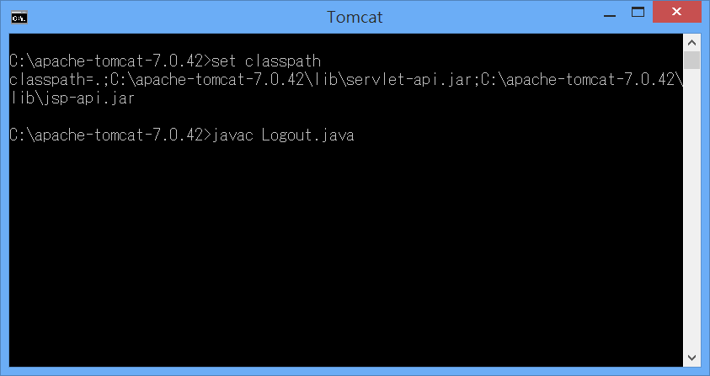

- 將上述程式複製到C:\apache-tomcat-7.0.42\webapps\ROOT\WEB-INF\classes
- 在C:\apache-tomcat-7.0.42\webapps\ROOT\LabLogin下，新增logout.xml。
<html>
<head>
<title>Servlet Logout</title>
</head>
<body>
<h1>使用者已登出</h1>
</body>
</html>
- 修改 web.xml
<servlet>
<servlet-name>MyLogin</servlet-name>
<servlet-class>Login</servlet-class>
</servlet>
<servlet-mapping>
<servlet-name>MyLogin</servlet-name>
<url-pattern>/login.do</url-pattern>
</servlet-mapping>
<servlet>
<servlet-name>MyUserView</servlet-name>
<servlet-class>UserView</servlet-class>
</servlet>
<servlet-mapping>
<servlet-name>MyUserView</servlet-name>
<url-pattern>/user.view</url-pattern>
</servlet-mapping>

<servlet>
<servlet-name>MyLogout</servlet-name>
<servlet-class>Logout</servlet-class>
</servlet>
<servlet-mapping>
<servlet-name>MyLogout</servlet-name>
<url-pattern>/logout.do</url-pattern>
</servlet-mapping>
9 執行 http://localhost:8080/LabLogin/login.html
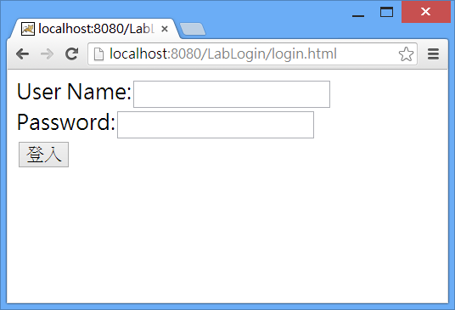

NetBeans製作Servlet Session
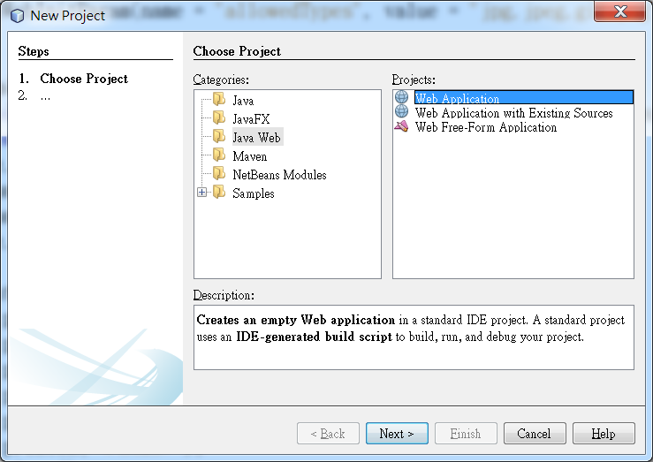
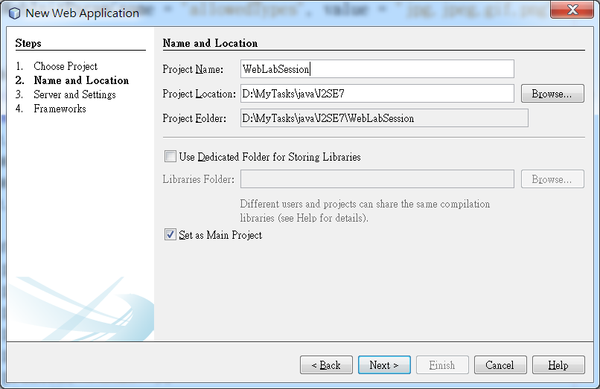
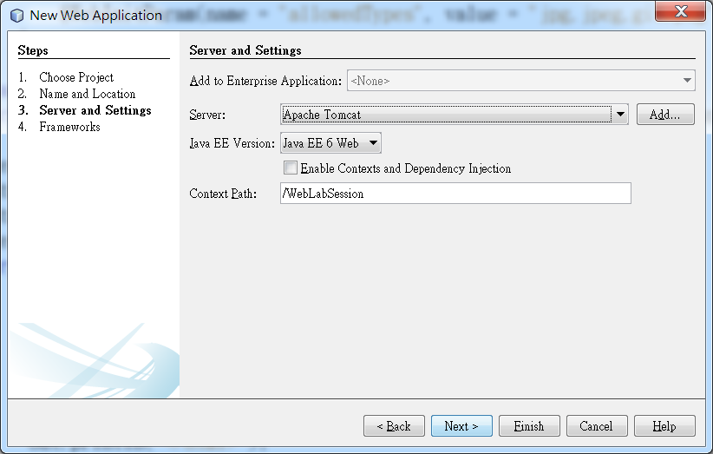

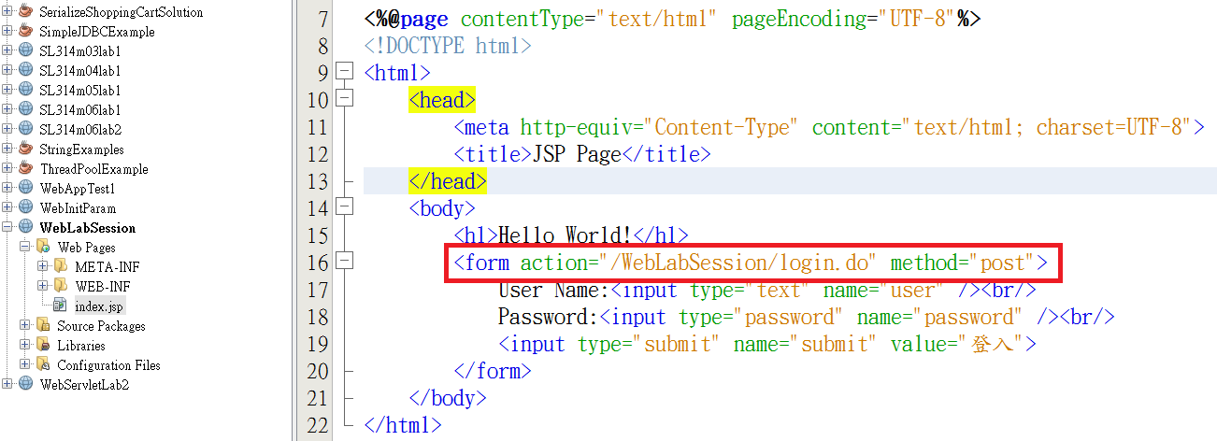
在default package 建立Login.java程式:
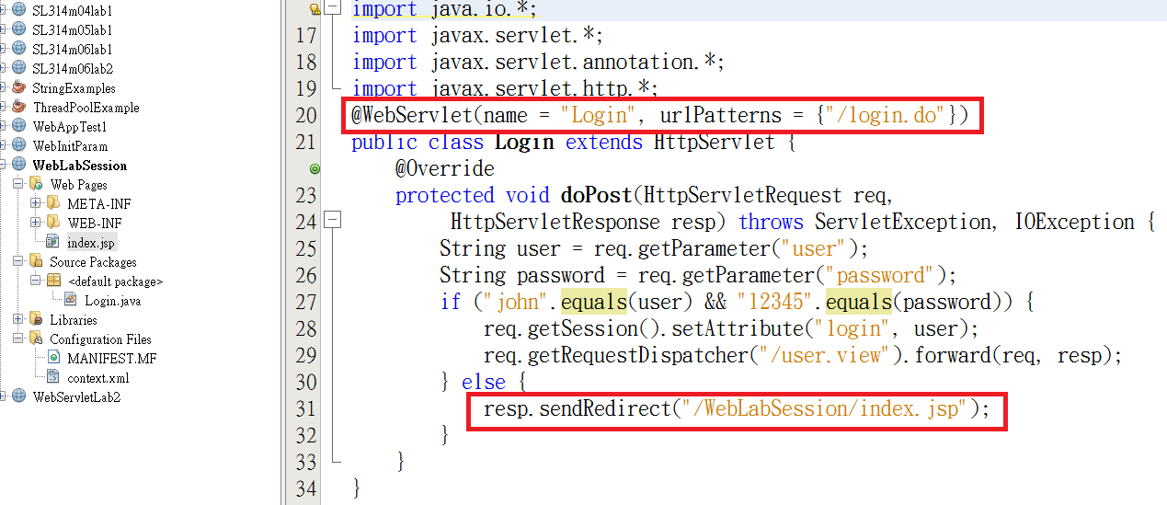
在default package 建立UserView.java程式:

import java.io.*;
import javax.servlet.*;
import javax.servlet.annotation.*;
import javax.servlet.http.*;
@WebServlet(name = "User", urlPatterns = {"/user.view"})
public class UserView extends HttpServlet {
protected void processRequest(HttpServletRequest request,
HttpServletResponse response) throws ServletException, IOException {
HttpSession session = request.getSession();
if (session.getAttribute("login") == null) {
response.sendRedirect("/WebLabSession/index.jsp");
} else {
response.setContentType("text/html;charset=UTF-8");
PrintWriter out = response.getWriter();
out.println("<html>");
out.println("<head>");
out.println("<title>歡迎 "
+ session.getAttribute("login") + "</title>");
out.println("</head>");
out.println("<body>");
out.println("<h1>Servlet User " +
session.getAttribute("login") + "</h1><br><br>");
out.println("<a href=\"logout.do\">登出</a>");
out.println("</body>");
out.println("</html>");
out.close();
}
}
@Override
protected void doGet(HttpServletRequest req, HttpServletResponse resp)
throws ServletException, IOException {
processRequest(req, resp);
}
@Override
protected void doPost(HttpServletRequest req, HttpServletResponse resp)
throws ServletException, IOException {
processRequest(req, resp);
}
}

在default package 建立Logout.java程式:
import java.io.*;
import javax.servlet.*;
import javax.servlet.annotation.*;
import javax.servlet.http.*;
@WebServlet(name="Logout", urlPatterns={"/logout.do"})
public class Logout extends HttpServlet {
protected void processRequest(HttpServletRequest req,
HttpServletResponse resp) throws ServletException, IOException {
req.getSession().invalidate();
resp.sendRedirect("/WebLabSession/logout.html");
}
@Override
protected void doGet(HttpServletRequest req, HttpServletResponse resp)
throws ServletException, IOException {
processRequest(req, resp);
}
@Override
protected void doPost(HttpServletRequest req, HttpServletResponse resp)
throws ServletException, IOException {
processRequest(req, resp);
}
}
在Web Page下建立logout.html
<html>
<head>
<meta http-equiv="Content-Type" content="text/html; charset=UTF-8">
<title>Servlet Logout</title>
</head>
<body>
<h1>使用者已登出</h1>
</body>
</html>

